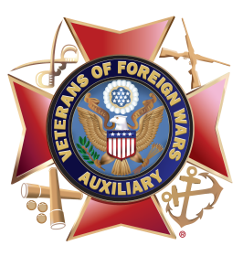**Family Freedom Festival**

*Sample Social Media Posts*

***Please note:*** The posts below are samples. The information will need to be changed to reflect each Auxiliary’s event.

**Sample Post 1:**  
Join VFW Auxiliary 12345 on Saturday, September 16 from 10:00 a.m. – 4:00 p.m. for our first ever Family Freedom Festival! This *FREE* family-friendly event includes a children’s bike parade, free face painting, and three arts and crafts stations. Food will be available for purchase from Three Little Pigs. The Auxiliary will be collecting bar soap, men’s and women’s socks, shampoo, conditioner and baby wipes for the community homeless shelter. The event will take place at VFW Post 12345 at 123 Main St. in Springfield. See you there! #AuxiliariesinAction #FamilyFreedomFestival

**Sample Post 2:**Does your family like to have FUN? Especially FREE FUN? Join VFW Auxiliary 12345 on Saturday, April 14 at our first-ever Family Freedom Festival. The event will feature a relay games, arts and crafts stations, cotton candy and popcorn, and music and will take place at Smith Park in Springfield. The Auxiliary will be collecting canned goods for the local food pantry. The fun begins at 4:00 p.m. and ends at 7:00 p.m. See you there! #AuxiliariesinAction #FamilyFreedomFestival

**Sample Post 3:**VFW Auxiliary 12345’s first-ever Family Freedom Festival is one week from today! We hope your family will join us for a fun-filled day of food, games and music at Smith Park in Springfield. The fun begins at 10:00 a.m. and lasts until 4:00 p.m. Remember to bring a non-perishable food item for the food pantry! The Auxiliary looks forward to seeing you at this free event! #AuxiliariesinAction #FamilyFreedomFestival